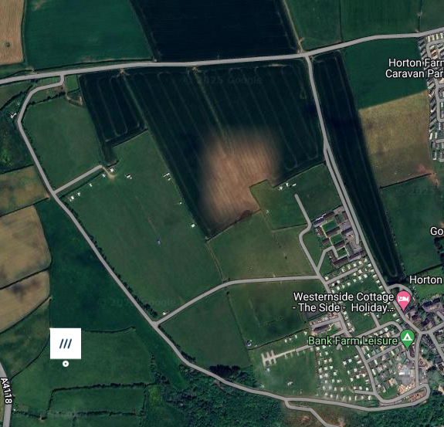
A4118
Bank Farm: Main Gate
what3words: prank.sprayer.slug
Reception
what3words:
droplet.silk.violinist
Chalet Lane
what3words: cherubs.potions.flitting

